August 2020 Board Meeting
August 26, 2020 6:30 – 8:00 p.m.
Cleveland Neighborhood Association

Organization Summary:
Cleveland Neighborhood Association works towards its mission by hosting regular events including youth events, monthly committee meetings engaging neighbors and city/county officials, and the popular Live On The Drive events, a summer concert and movie series that draws neighbors from nearby neighborhoods, and visitors from the Twin Cities region at large.

Mission Statement:
Cleveland Neighborhood Association’s mission is to foster and cultivate a safe, diverse, and forward-thinking neighborhood by building relationships, inspiring community members and embracing local opportunity for the betterment of the lives of the residents of Cleveland Neighborhood.

Meeting Codes of Conduct
- All members and guests must sign in and sign up if they would like to participate in meeting
- Please turn sound off on any electronic devices during board meetings
- Guests may not speak unless permissible by board chair
- Guests may not speak during any motions
- We will stick to the schedule, if there is something that needs further discussion past the time allowed for that line item it must be tabled until the end of the meeting during announcements.

Meeting called to order at 6:33pm
Attendance: Meredith Hyduke Dehn, Brenda Hasan, Armando Zentella, Patricia Crumley, Matt Jarolimek, JoAnne Middaugh, Wesley Farrow, Kate Herman
Members:
- Guests: Robert Thompson, Erin, Ariah Fine, Erin Russ, Barb, Bill Magnuson, Dani Tietjen, Steve Gallagher
- Excused Absences:
- Unexcused Absences: Cynthia

Agenda
- Call the meeting to order 6:30pm
- Approval of July Minutes / 6:35pm
Treasurer and Financial Update
- MPD Comm. Liaison & Community Safety 6:40pm
- Executive Update 6:50pm
- Green Committee 7:00pm
- Community Development 7:05pm
- New Business/Board Discussion 7:35pm
- Adjourn 8:00pm

Motions

July Agenda Approval
DISCUSSION: | Postponed. Secretary Meredith will send it out after the meeting.
MOTION STATED: | MOTION MADE BY: | MOTION SECONDED BY:

Nays or Abstentions?

July Finances and Treasurer Report
MOTION STATED: | MOTION MADE BY: | MOTION SECONDED BY:
Motive to approve July finances | Matthew | Pat

nays or abstentions?
None

Executive Report
DISCUSSION: | Need to buy a new computer for the CNA office. Need the office cleaned, with COVID we will take shifts cleaning. Will have sanitizer available. Brenda and Kate’s 2nd term is up. Kate will run again, Brenda will return. Pat, Tommy, and Meredith are ended their 1st term. Tommy and Pat will run again, Meredith will not.
MOTION STATED: | MOTION MADE BY: | MOTION Seconded by:
Motion to approve the purchase of a new computer for close to $500 for the executive office | Tommy | Pat

Nays or abstentions?

MPD Comm. Liaison & Community Safety
DISCUSSION: | Surveillance Program- 10 new requests April through now. Pat and Tommy will work together to deliver a check for the rebate program.  Bill Magnuson shared crime maps from July and August. Increase in theft and assault from July to August. Total from July was 9, August is 15.
MOTION STATED: | MOTION MADE BY: | MOTION SECONDED BY:

Nays or abstentions?

Green Committee
DISCUSSION: | “Litter Be Gone”, clean-up will be at the garden on October 3rd at 10am. One of the community garden members had all her produce stolen, we will buy her a $50 gift card to North Market to thank her for commitment.
MOTION STATED: | MOTION MADE BY: | MOTION SECONDED BY:

Nays or abstentions?

Community Development Committee
DISCUSSION: | We will discuss the 2020 Census update next month.  we reviewed the 2020 budget letter with Steve Gallagher (view in picture below or via this link  - Steve Gallagher explained that NPR will be experiencing a cut in their department from the city’s shortfall. This will not mean a cut to current neighborhoods accounts.  - Would be wise to spend our current unassigned (uncontracted) NRP funds (18k).  - 35th and Penn. Discussed with Steve Gallagher to make sure we have funds available. Steve suggested we talk with someone in city planning (CPED). Ariah Fine joined to answer questions. He said that a letter of intent was sent to the seller. For more information on the board proposal discussion see below.  MOTION: Board Action:  Approve a commitment of funds to the Northside Investment Cooperative Enterprise (NICE) to acquire 3445, 3449, and 3501 Penn. Including:  - Phase II NRP Lot Redevelopment Funds $145,833.28  - Phase III CPP Reserve Funds $10,000  - Phase I NRP Implement Lowry/Penn Strategic Plans $2,050.00  Direct CPED to work with NICE to contract the funds for the property acquisition to launch an investment cooperative focused on community ownership and local businesses.  Funding will be contingent on (include as many of these as you think would be important to the approval of the board):  - Additional funding being identified and approved for property acquisition  - Purchase agreement and closing on said property  - Supportive approval of project funding by 40 Cleveland residents by October 31st  - Expanded NICE board leadership to 6 members by Closing date  - Expanded NICE dues paying membership to 25 by Closing date  - Commitment from community partners to be identified, such as City of Lakes Community Land Trust or Twin Cities Land Bank  - With final contingencies to be specified within 30 days  - To determine clarification if board members also be investors  Decisions regarding funding:  - Up to $155,000 no-interest 5-year forgivable loan contingent on expanding membership to 200 members  - All funding contingent on Penn Properties remaining in possession of NICE MN for the intended uses for 15 years  All of this goes to CPED to actually finalize all the agreements and contingent on their own legal and development due diligence.
MOTION STATED: | MOTION MADE BY: | MOTION Seconded by:
Matthew moved to approve the motion as presented | Matthew | Kate

Motion to move annual meeting to September 23rd from October | Tommy | Kate

Nays or abstentions? | None

Board Discussion: Discuss Annual Meeting- Moving the annual party to September, making it an outdoor event. Tommy will work on creating a newsletter to have ready for this weekend. Any information that should be on the newsletter should be sent to Tommy by tomorrow 8/27.
Need someone to take minutes for next month’s meeting.
MPD Community Liaison: Bill Magnusson (see community safety)
Community Member: Ariah Fine (See Community Development notes)
Robert Thompson: Attended and gave an update on Finances and his work with Mike Wilson to examine Finances. Some contracts that are reimbursable through the city that we will be working on. For specific details see financial Report July 2020. Robert suggests reducing risks by making sure different people are writing the checks and reconciling budget. Ask suggests a budget be made every year.

Announcements

Adjourn
Kate moved that the meeting be adjourned, and this was seconded by JoAnne at 8:51 pm

_ ________ __________
Secretary Date of Approval
Cleveland Neighborhood Association (write in date next month)

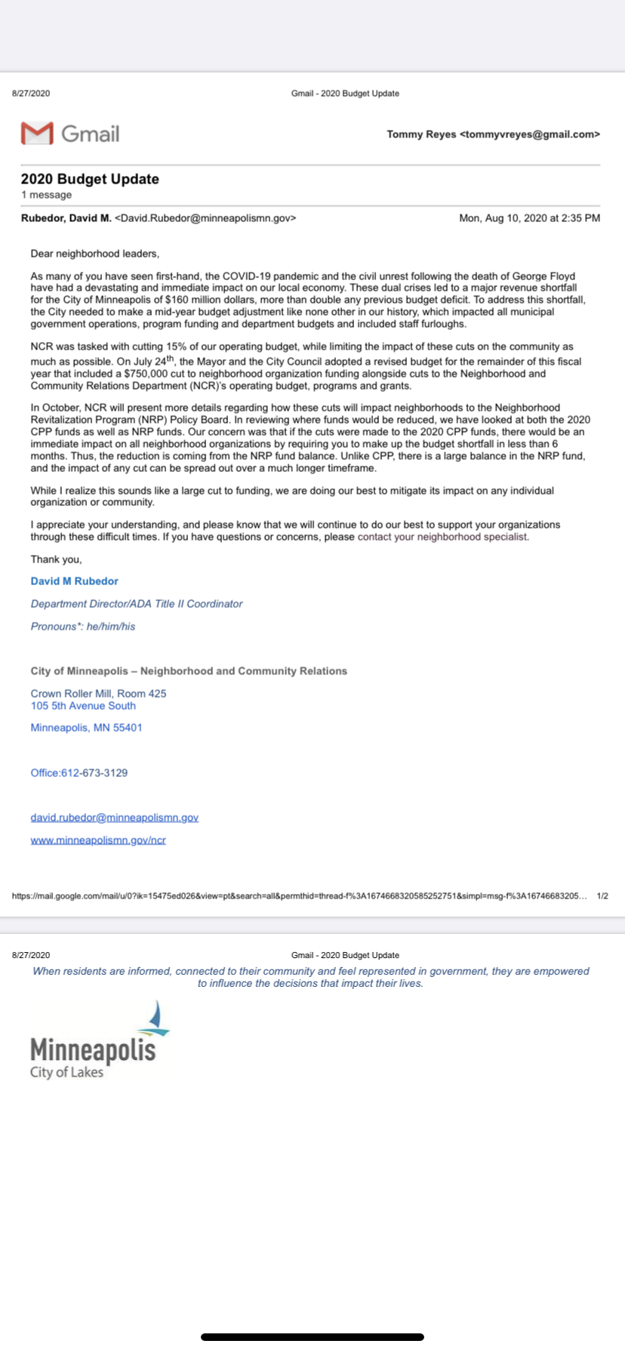

35th and Penn-NICE MN proposal

Approve a commitment of funds to the Northside Investment Cooperative Enterprise (NICE) to acquire 3445, 3449, and 3501 Penn. Including:
• Phase II NRP Lot Redevelopment Funds $145,833.28
• Phase III CPP Reserve Funds $10,000
• Phase I NRP Implement Lowry/Penn Strategic Plans $2,050.00
Direct CPED to work with NICE to contract the funds for the property acquisition to launch an investment cooperative focused on community ownership and local businesses.
Funding will be contingent on (include as many of these as you think would be important to the approval of the board):
• Additional funding being identified and approved for property acquisition
• Purchase agreement and closing on said property
• Supportive approval of project funding by 40 Cleveland residents by October 31st
• Expanded NICE board leadership to 6 members by Closing date
• Expanded NICE dues paying membership to 25 by Closing date
• Commitment from community partners to be identified, such as City of Lakes Community Land Trust or Twin Cities Land Bank
• With final contingencies to be specified within 30 days
• To determine clarification if board members also be investors
Decisions regarding funding:

• Up to $155,000 no-interest 5-year forgivable loan contingent on expanding membership to 200 members
• All funding contingent on Penn Properties remaining in possession of NICE MN for the intended uses for 15 years

All of this goes to CPED to actually finalize all the agreements and contingent on their own legal and development due diligence.

